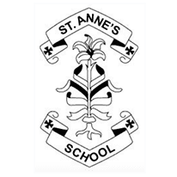

Dialogic Reading EYFS

Dear Parents/Carers,
As a school, we have decided to follow a reading strategy called Dialogic Reading. We want to help develop the children’s ‘Love for Reading.’ We have chosen books that reach the interests of our children, books that reflect our passion and enthusiasm towards reading and books that are linked to the wider school such as ‘Stick Man’ to introduce rhyming skills and ‘The Enormous Turnip’ to enhance Harvest discussions. The books chosen include story books (fiction), information books (non-fiction), rhymes and poems.
What is Dialogic Reading?
Dialogic Reading was originally created in the 1990’s by an American developmental psychologist called Dr Grover Whitehurst. He proposed a reading technique called the PEER sequence, which is a way of interacting between the adult and the child. Dialogic Reading is a strategy where, you read with them, instead of to them. Here, we will ask the children questions about what is happening, what they think might happen next, having a forward and backwards conversation.
PEER Sequence
P – Prompt – encourage the children to talk about the book. (Below are examples of how a child could be prompted to speak.)
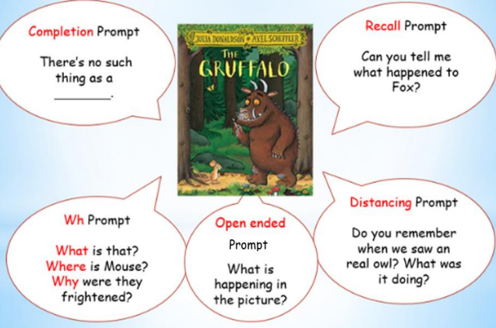

E – Evaluate the response e.g “that’s right.”
E – Expand on the response e.g “He’s a little brown mouse.”
R – Repeat the prompt, e.g. “Can you say “He’s a little brown mouse?”

“Dialogic reading works. Children who have been read to dialogically are substantially ahead of children who have been read to traditionally on tests of language development. Children can jump ahead by several months in just a few weeks of dialogic reading. We have found these effects with hundreds of children in areas as geographically different as New York, Tennessee, and Mexico, in settings as varied as homes, preschools, and day-care centres, and with children from economic backgrounds ranging from poverty to affluence”. Grover J. (Russ) Whitehurst (2002)

In EYFS, we have chosen a list of 50 books, 25 in Nursery and 25 in Reception. We aim that the children will be able to tell all 25 stories by the end of the school year. We know that this will not be word for word, but we hope that the children will be able to pick up the book and retell the story.
We have already had books donated to school to help us set up our Reading Areas, Outdoor Reading Sheds and to start a Library, which we are extremely grateful for.
We have already seen a love of reading and the impact in our Reading Areas in school of the children independently reading the books aloud to themselves, or friends.
Below I have added the 50 books that EYFS will be reading this year.
